MODIFY AND PUSH DOCKER IMAGES FROM DOCKER HUB:

BY A.ANGELENA

22BD1A0585

1. Pull the Ubuntu image

docker pull ubuntu

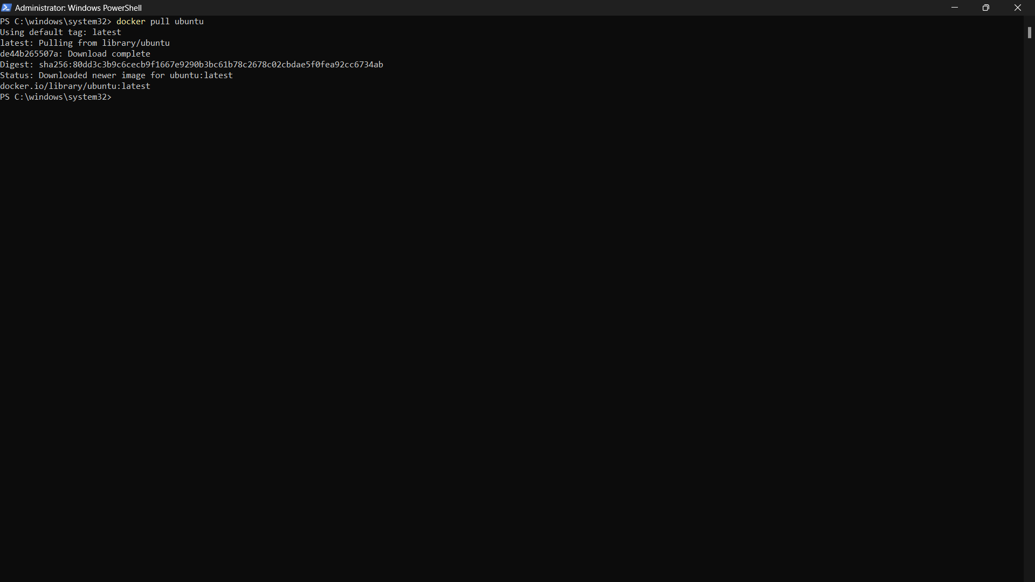

1. Run a container from the Ubuntu image

docker run -it --name newubuntu -d ubuntu

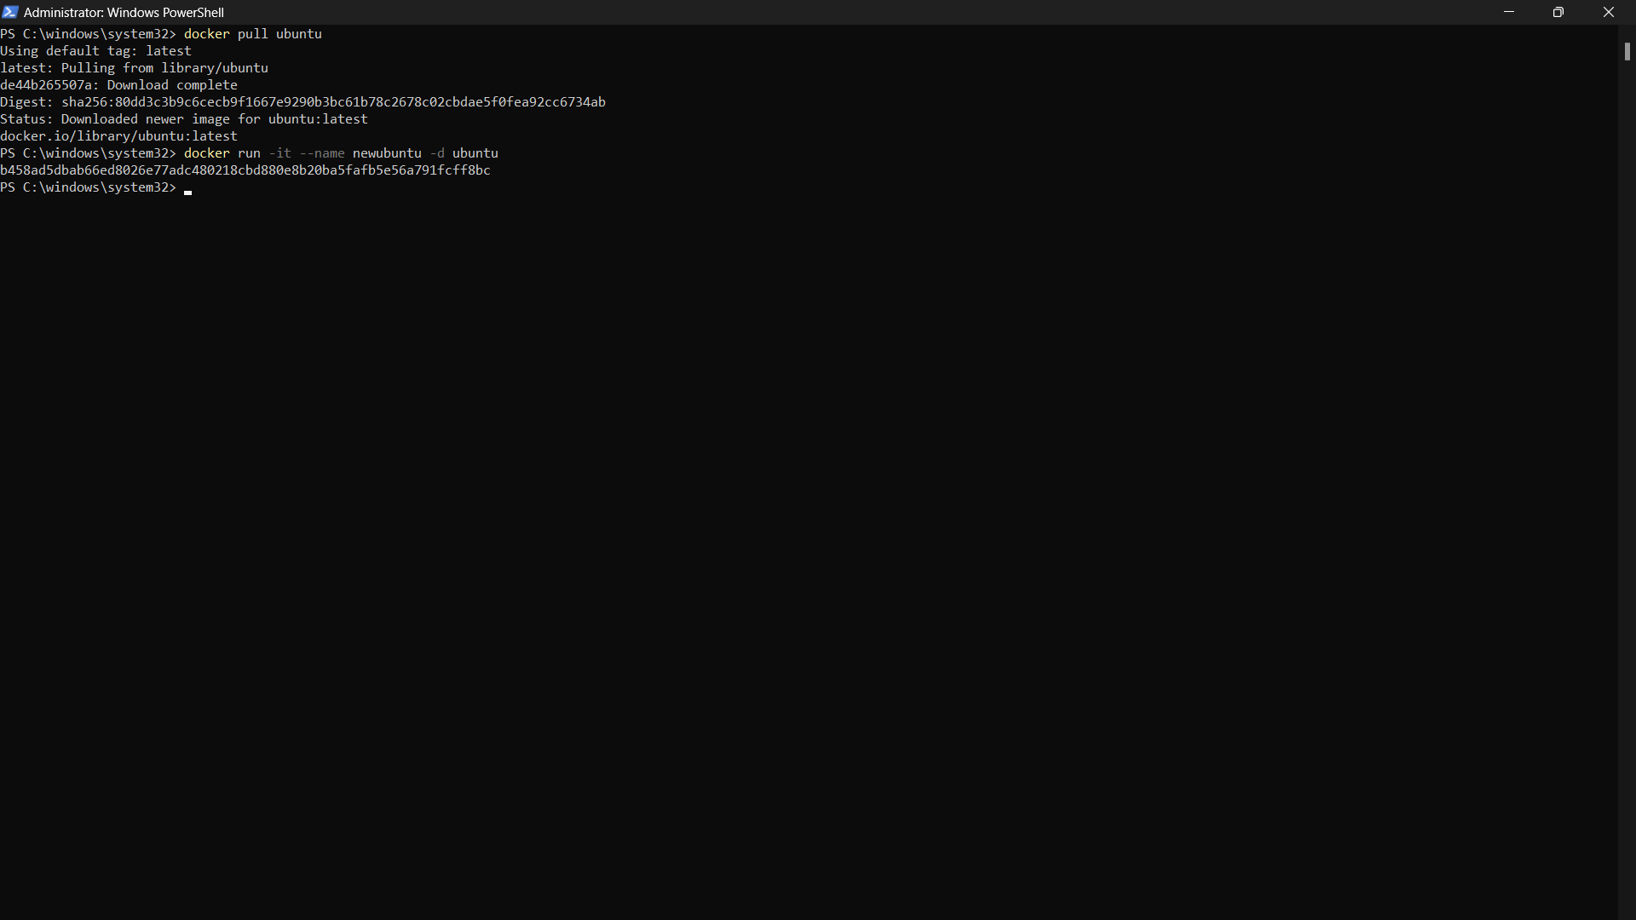

1. List all running containers

docker ps

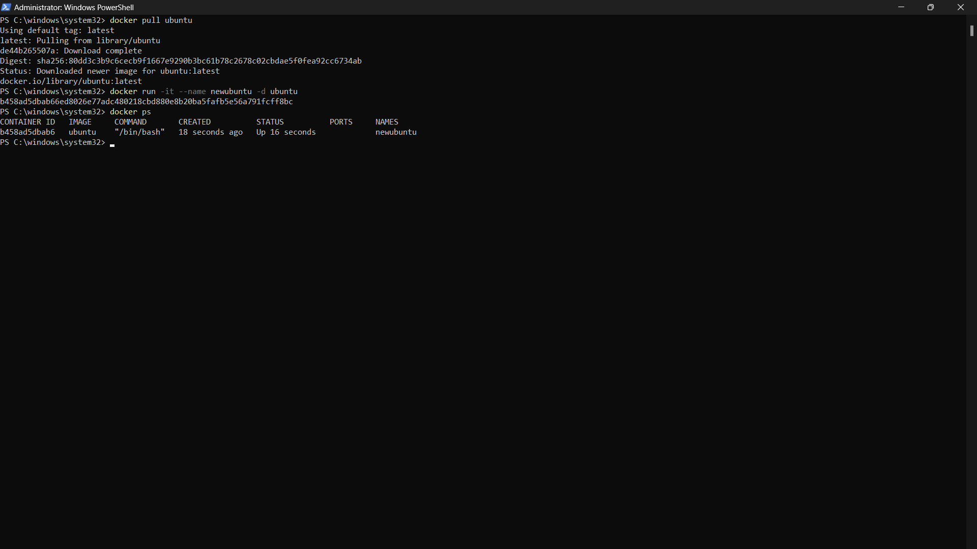

1. Access the running container

docker exec -it 885a01bcdbe0 bash

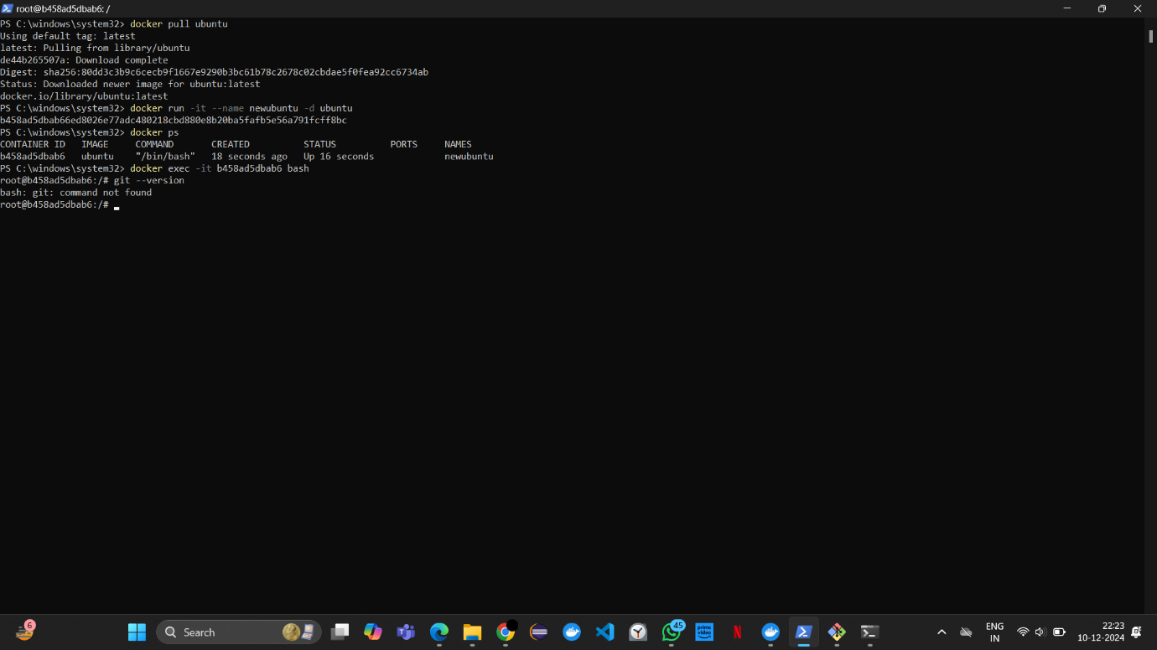

1. Check if Git is installed

git –version

The error bash: git: command not found means Git is not installed in the container.

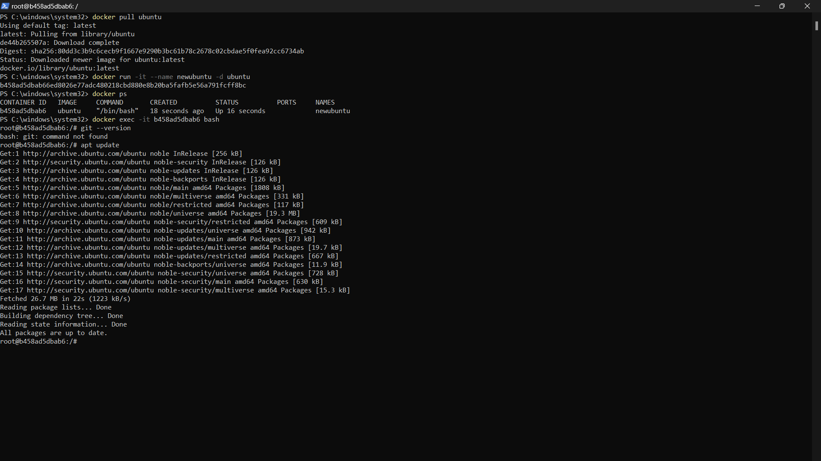

1. Update the package list

apt update

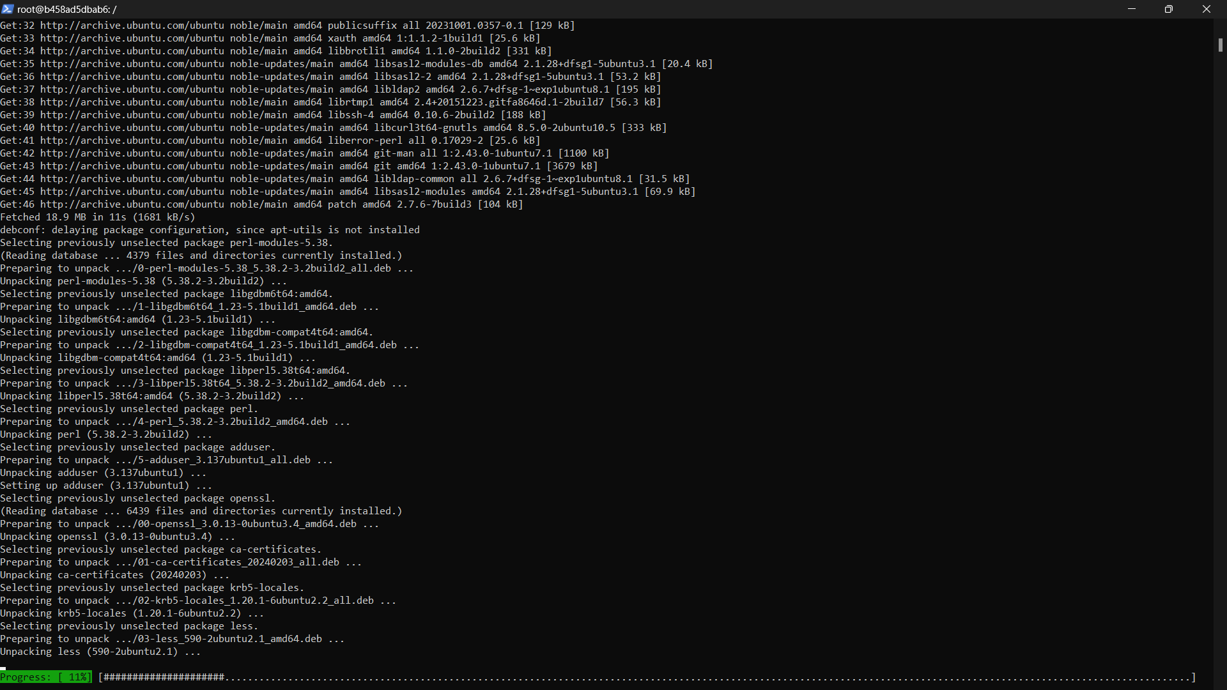

1. Install Git

apt install git -y

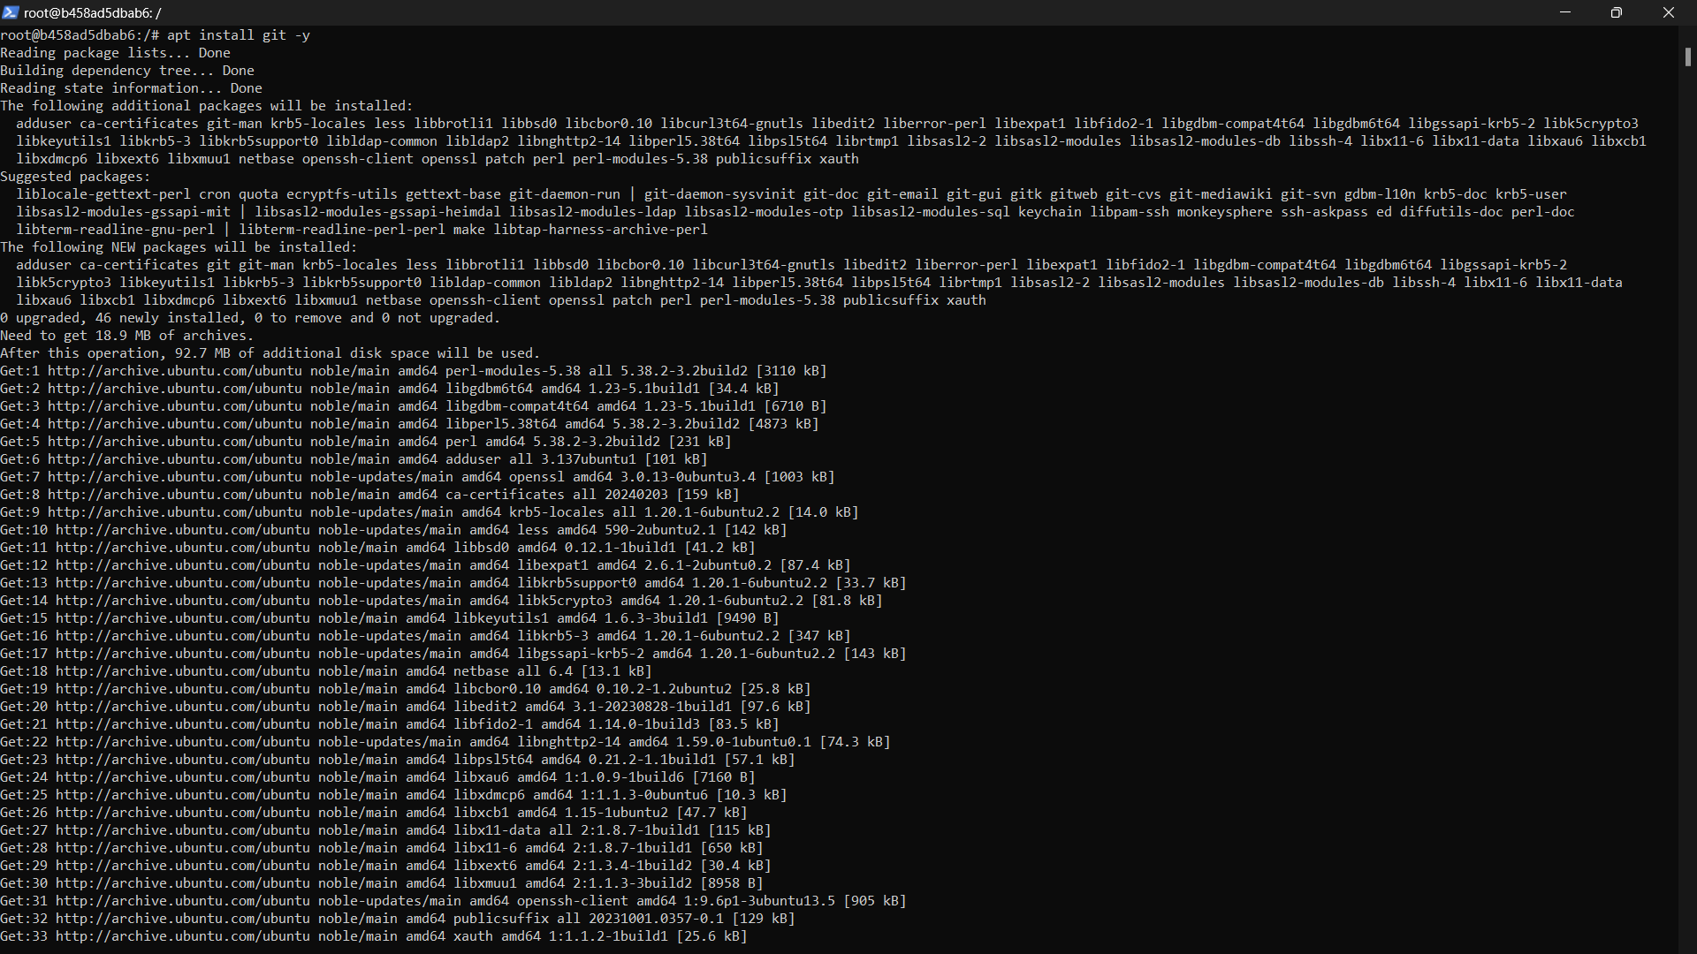

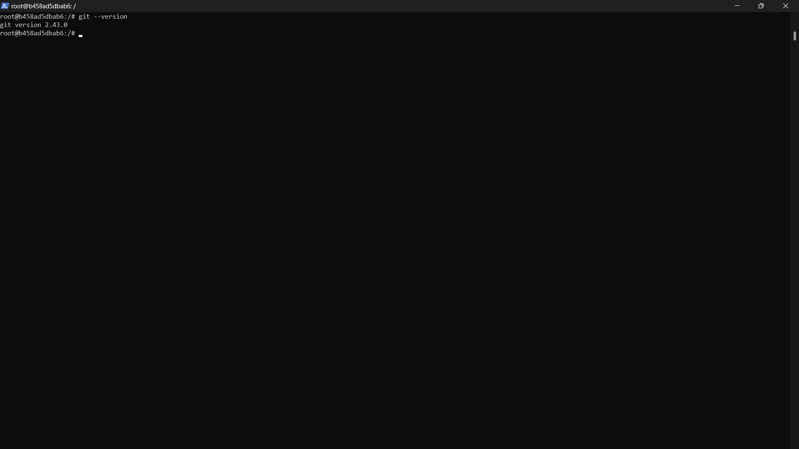

1. Verify Git installation

git --version

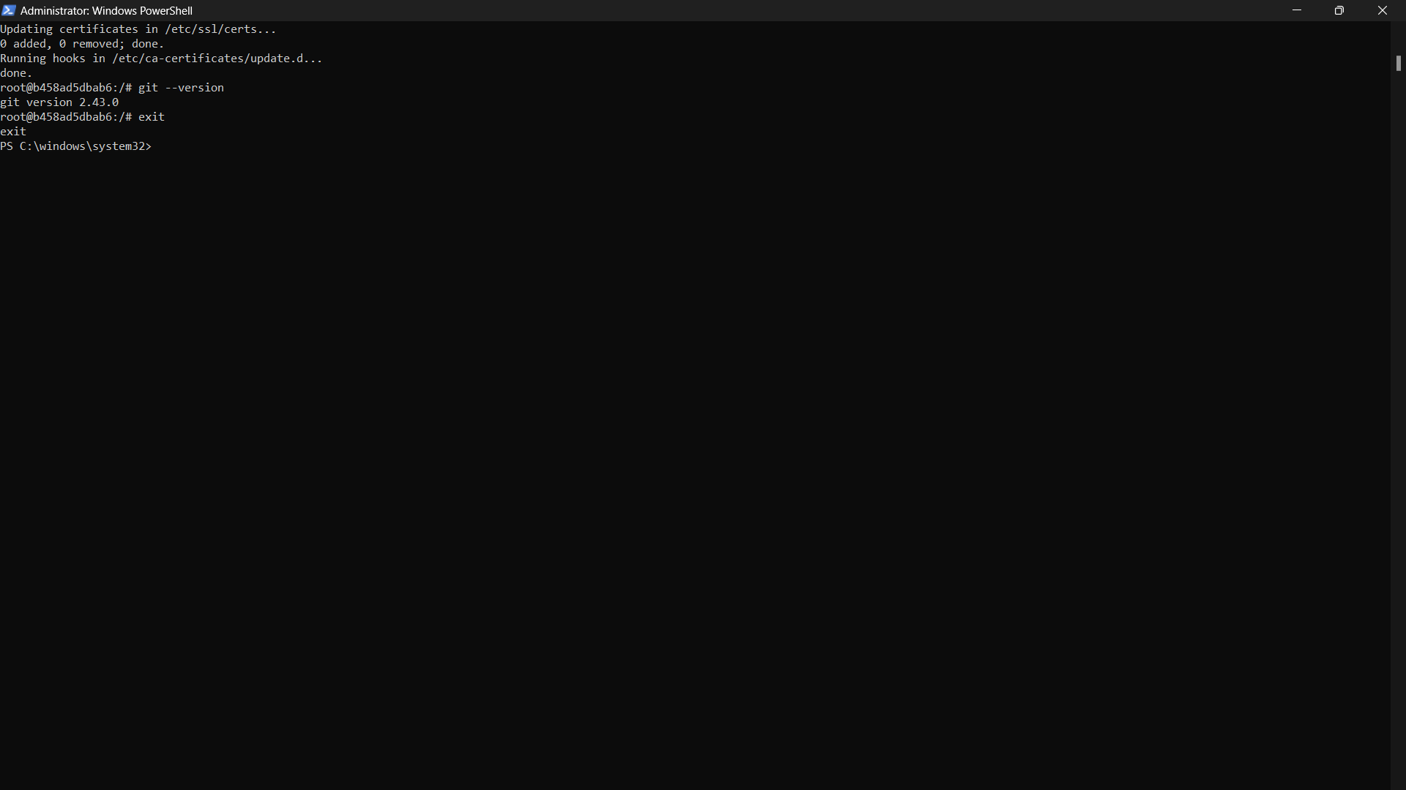

1. Exit the container

exit

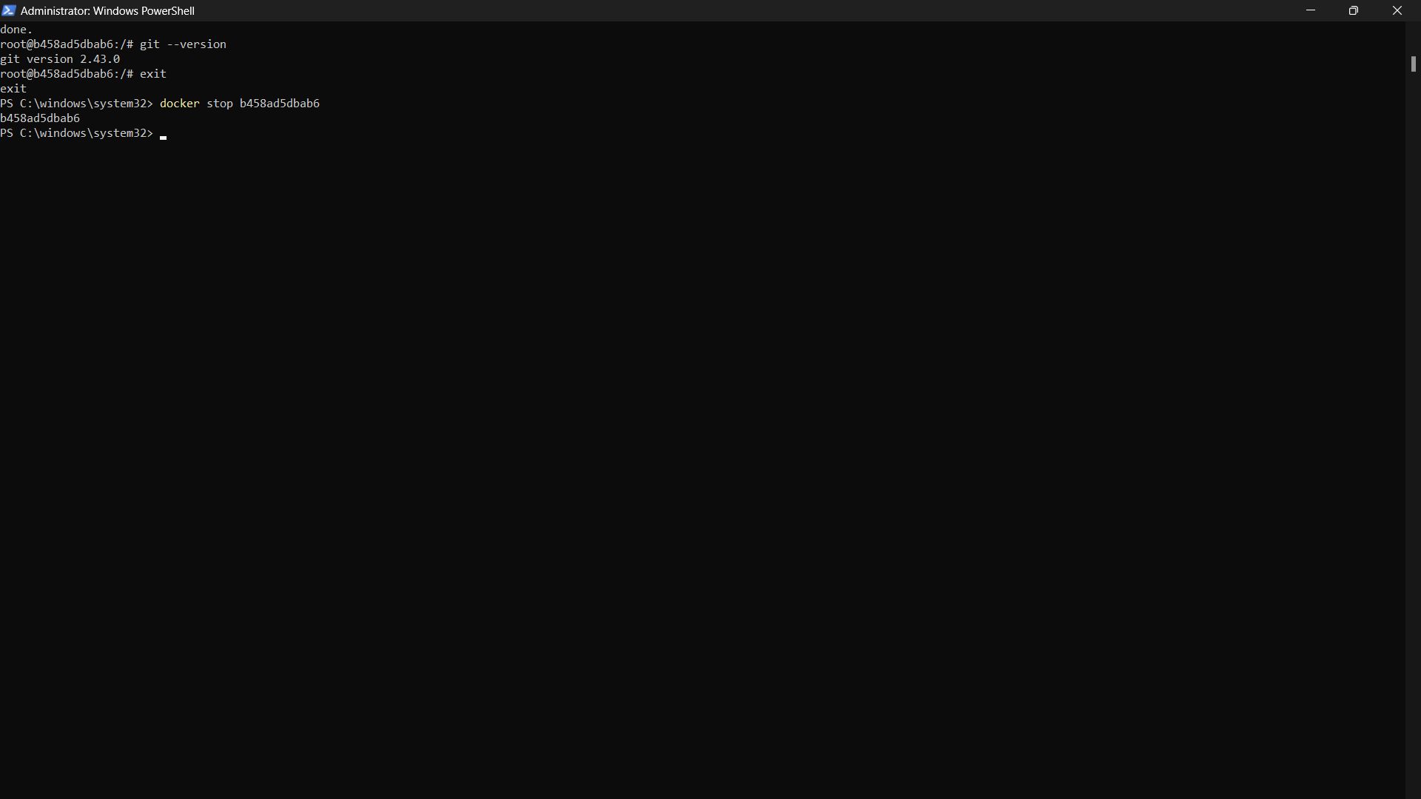

1. Stop the running container

docker stop 885a01bcdbe0

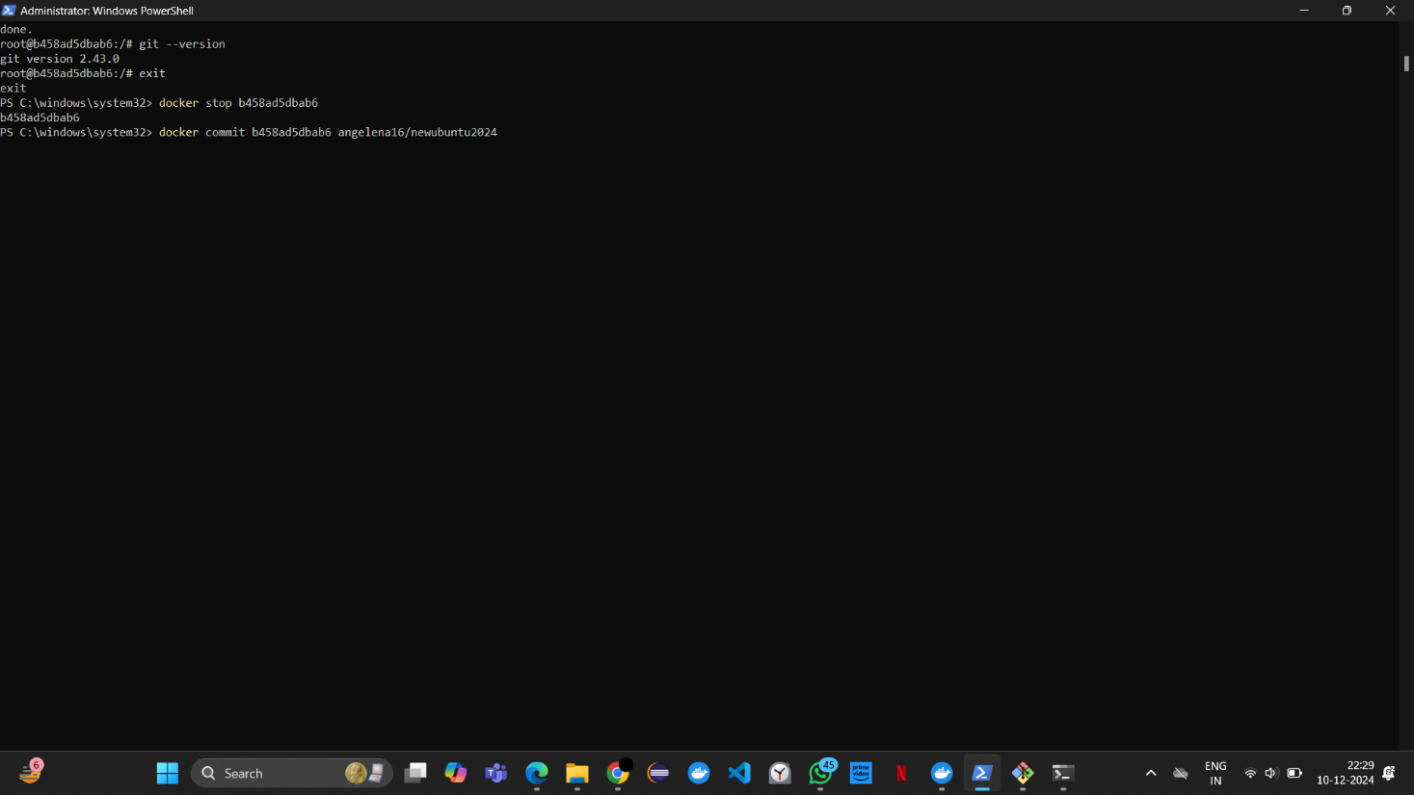

1. Save the container as an image

docker commit 885a01bcdbe0 angelena16/newubuntu2024

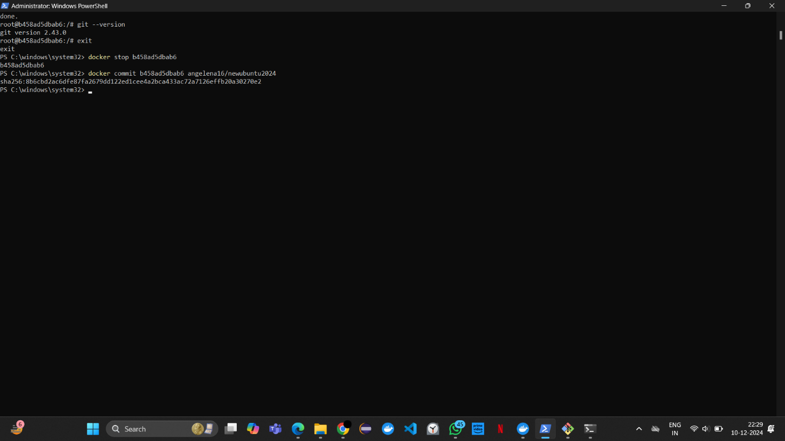

1. List all local images

docker images

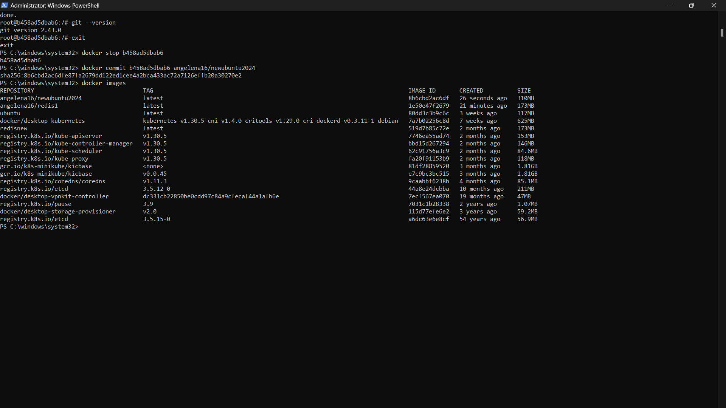

1. Log in to Docker Hub

docker login

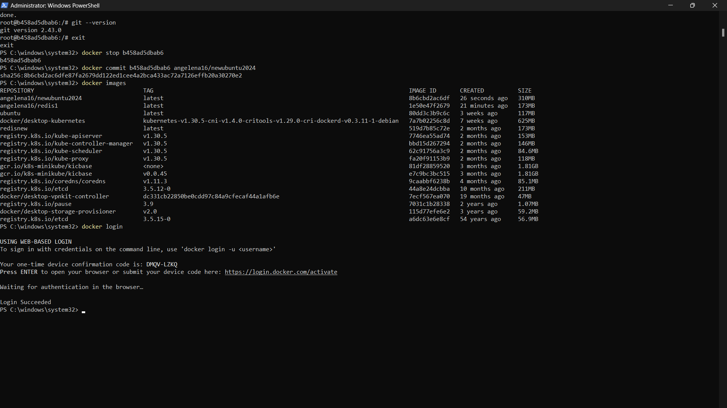

1. Push the image to Docker Hub

docker push angelena16/newubuntu2024

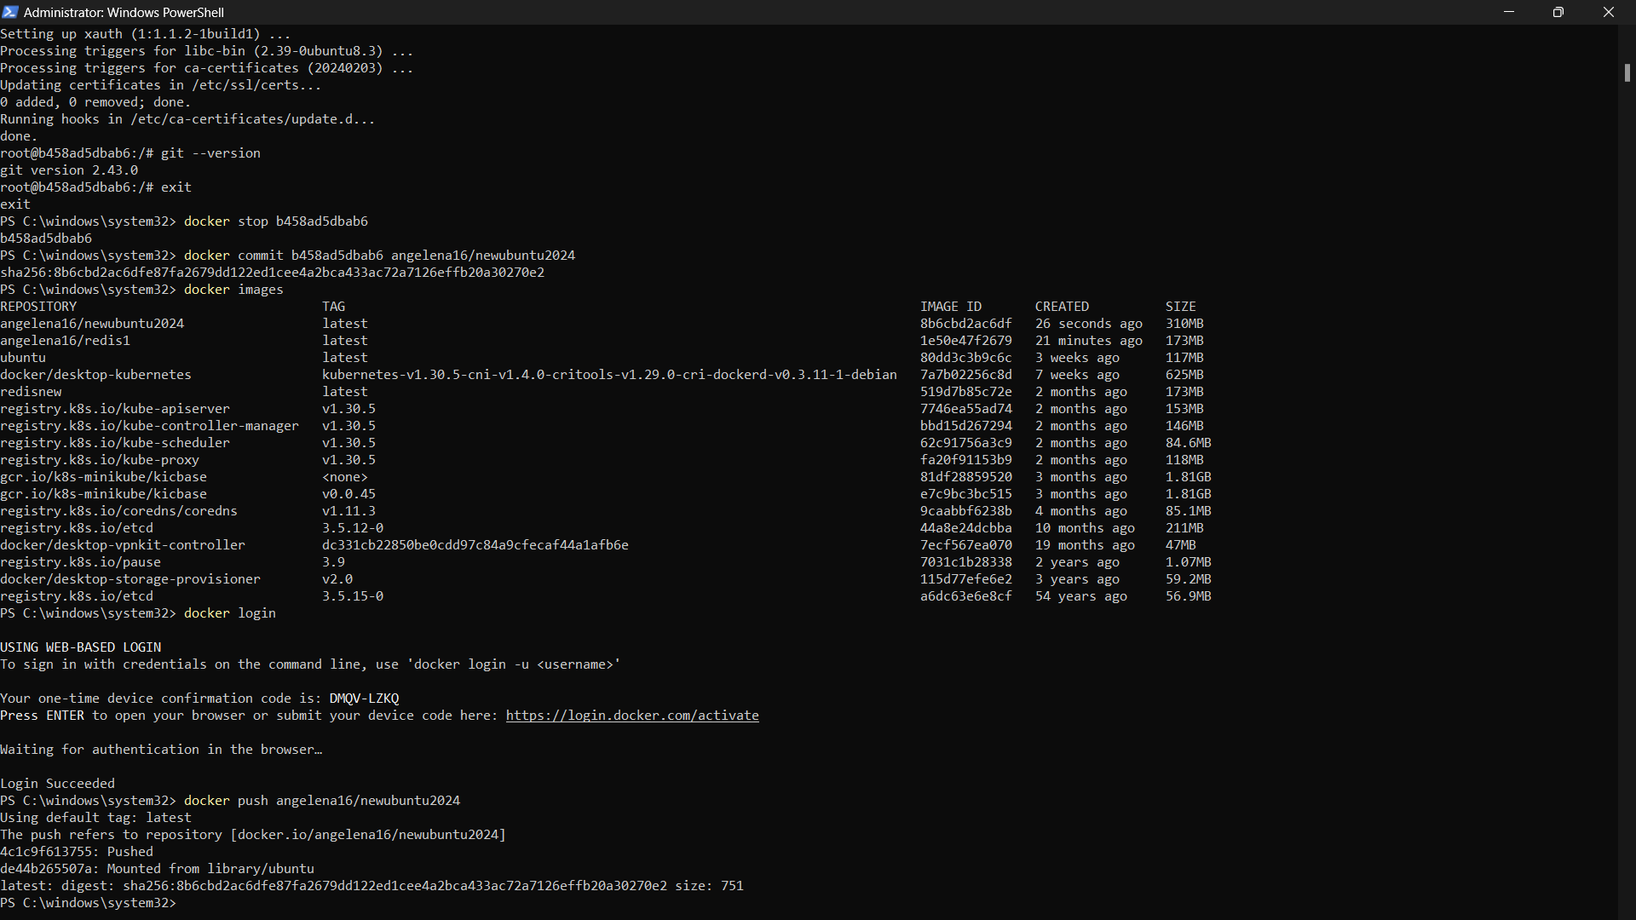

1. Log out of Docker Hub

docker logout

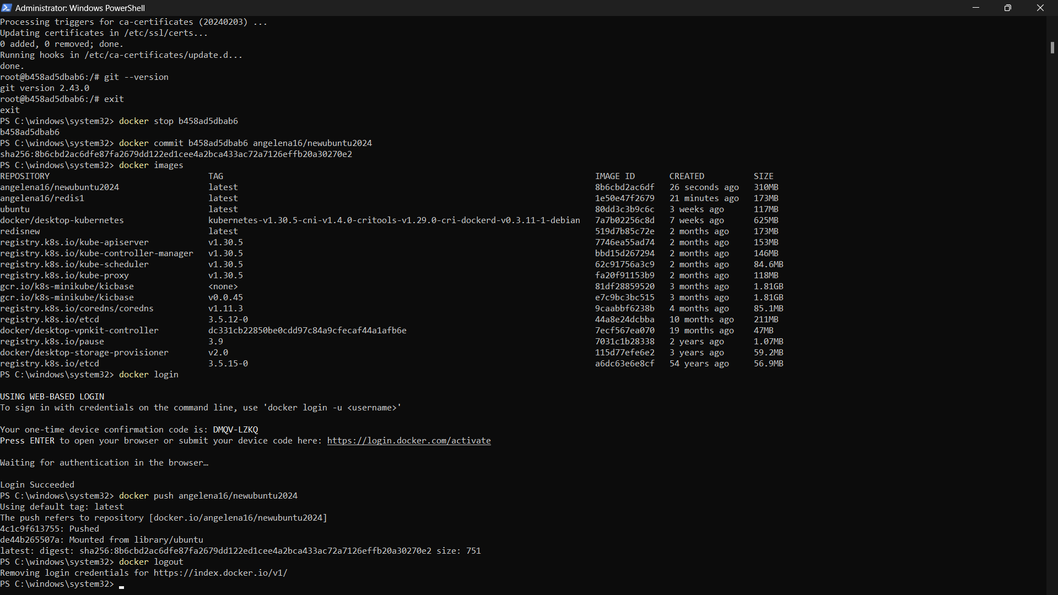

1. Remove the container

docker rm 885a01bcdbe0

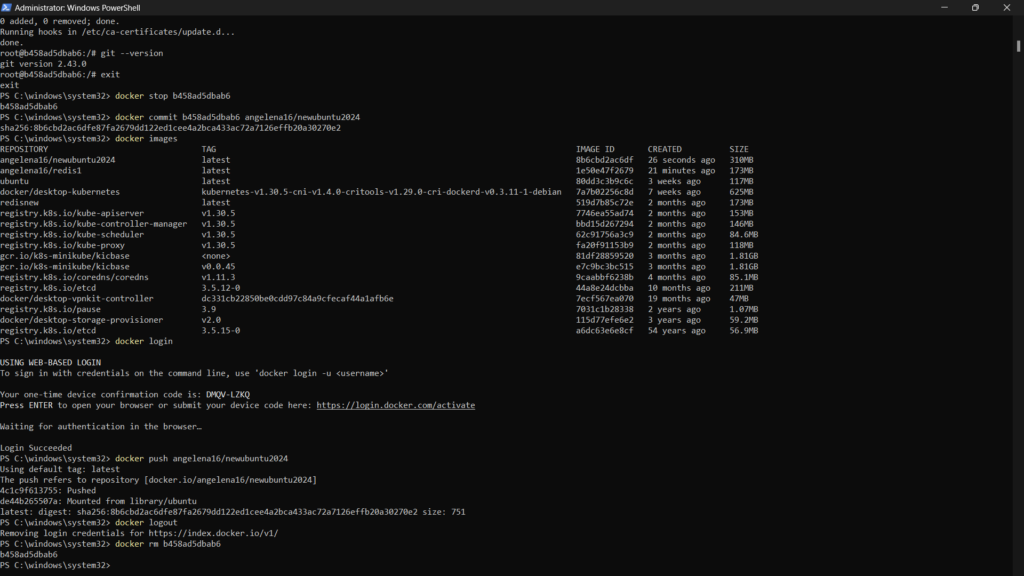

1. Remove the local image

docker rmi angelena16/newubuntu2024

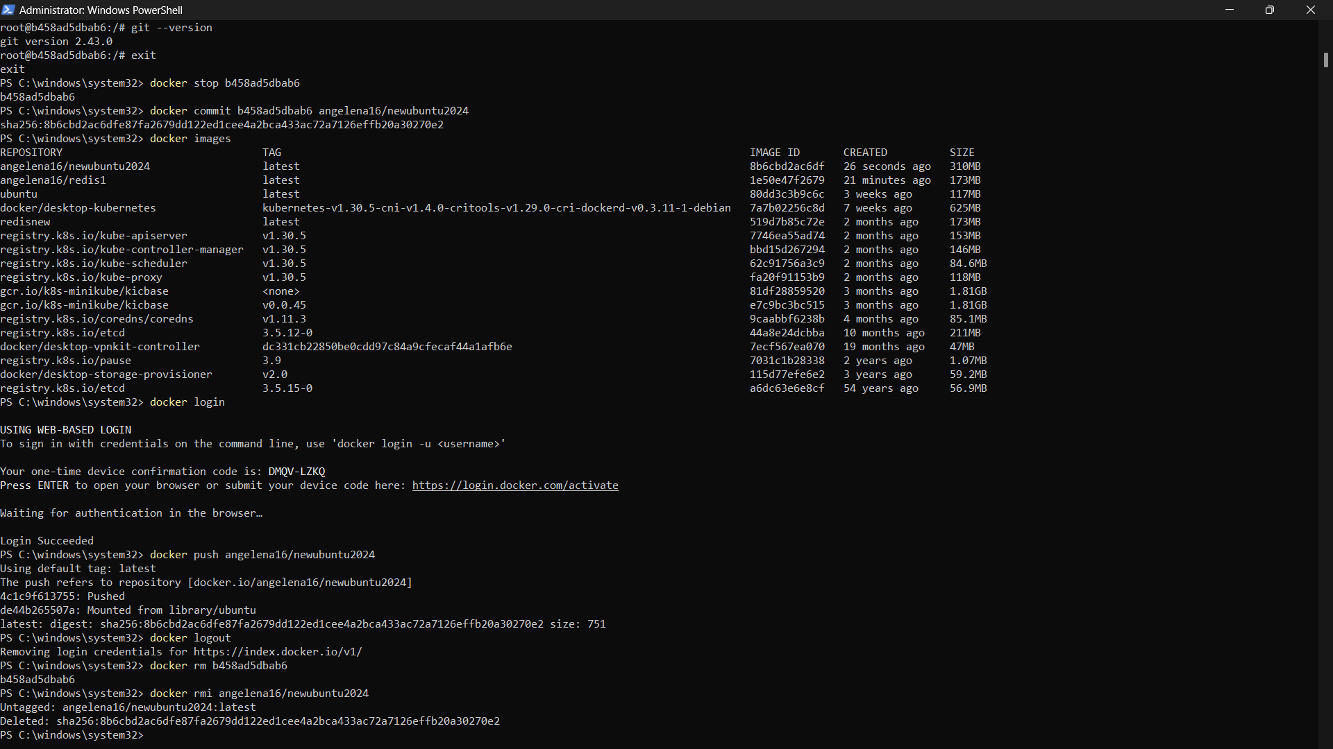

1. Pull the image from Docker Hub

docker pull angelena16/newubuntu2024

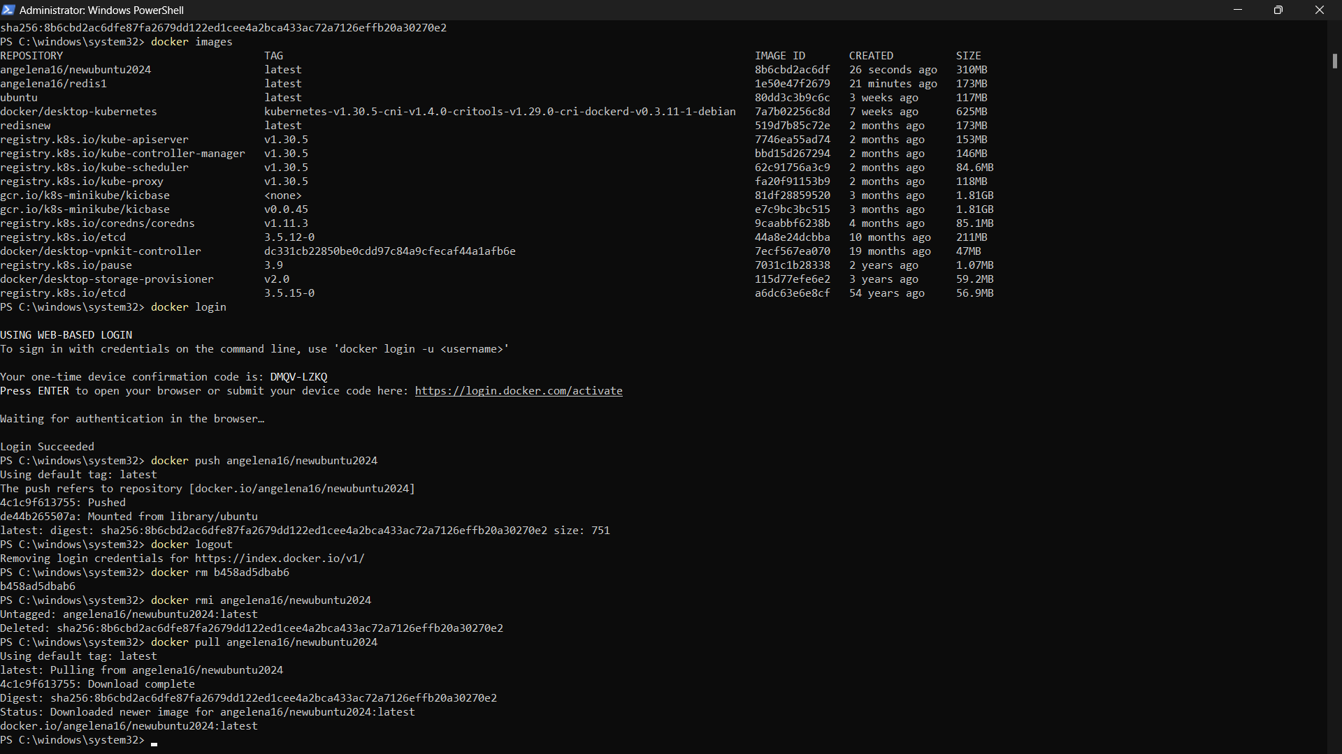

1. Run a container from the custom image

docker run --name newubuntu2024 -it angelena16/newubuntu2024

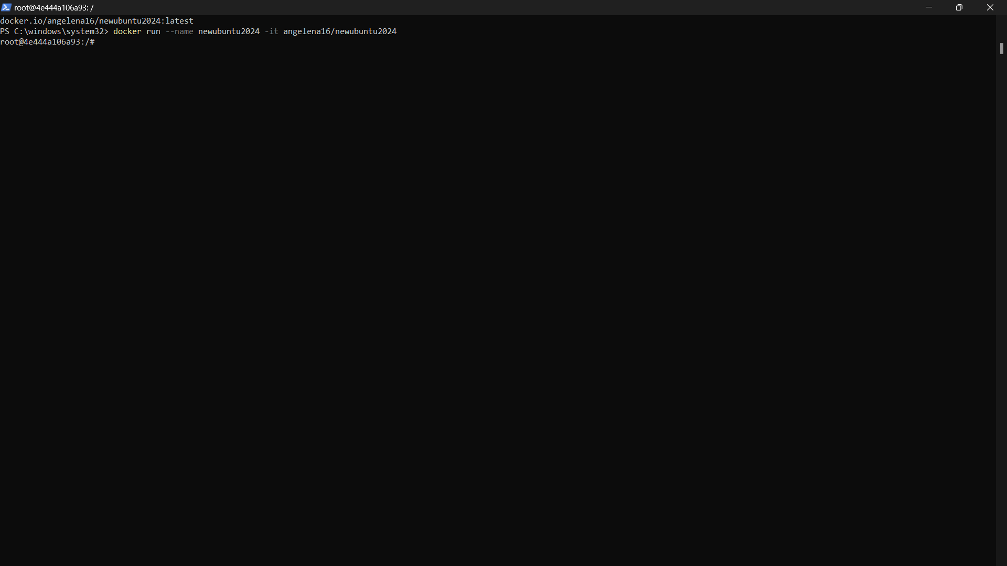

1. Check Git version

git --version

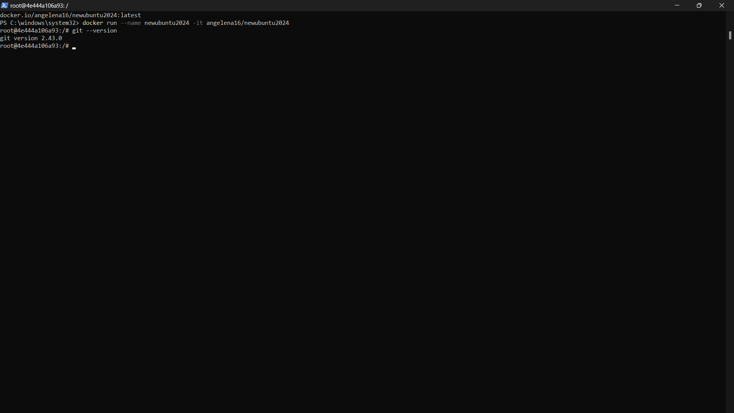

1. Exit the container

exit

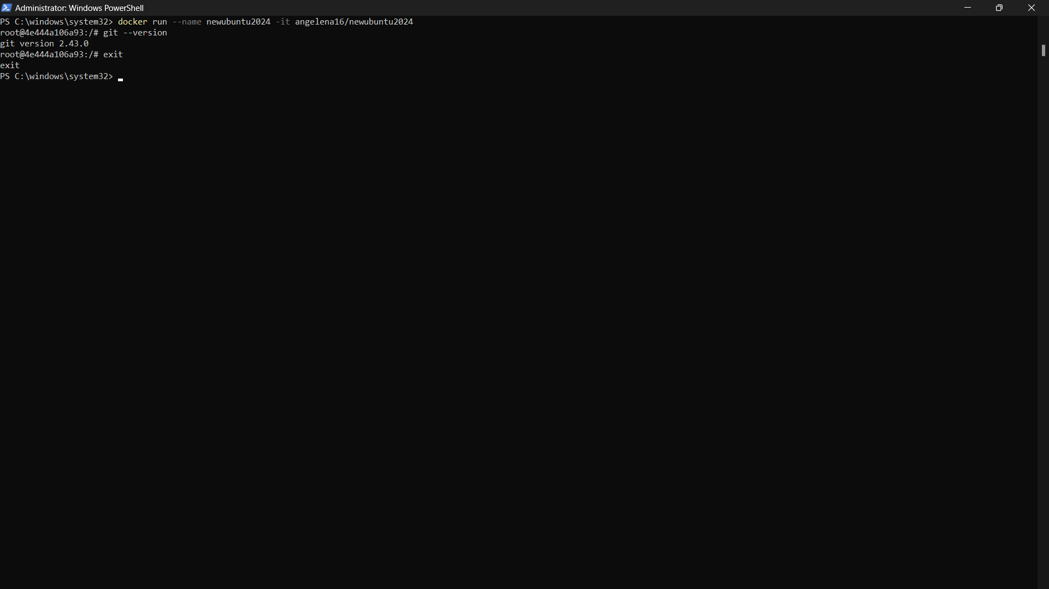

1. List all containers (including stopped ones)

docker ps -a

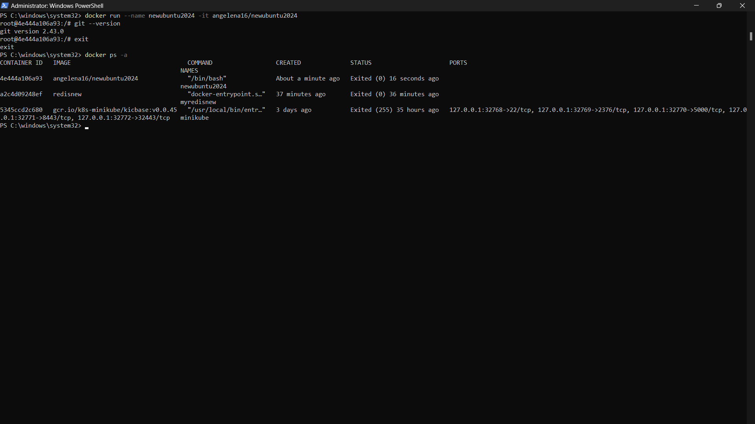

1. Remove the container

docker rm 28aee36085cb

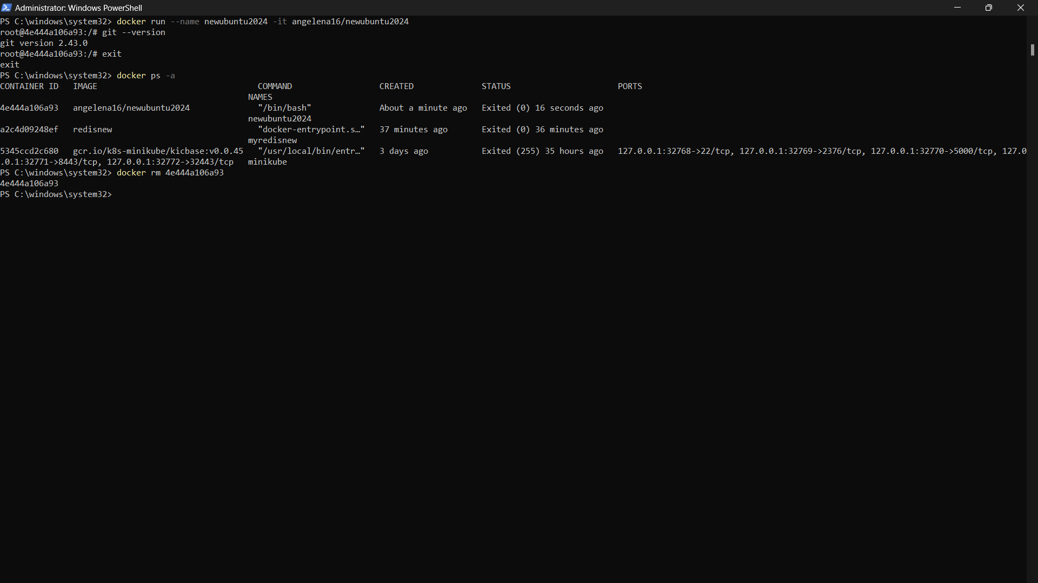

1. Remove the custom image

Docker rmi angelena16/newubuntu2024

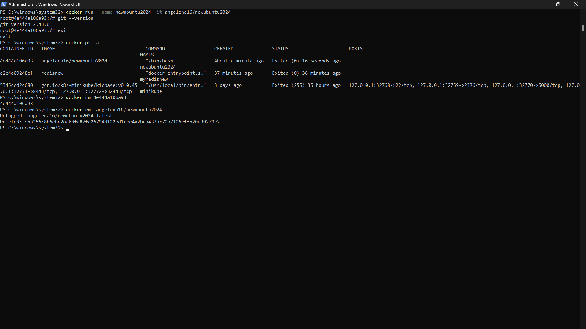

AND WE ARE DONE!!!